



Computer science fundamentals and career pathways
B.TECH CSE CORE SECTION (A) SEMESTER - 1
Course code : ETCCcp105
ASSIGNMENT TITLE :
SUBMITTED BY : MANPREET KAUR
Roll number : 2501010070
SUBMITTED TO : rajesh kumar sir
DATE OF SUBMISSION : 10 november 2025

INTRODUCTION

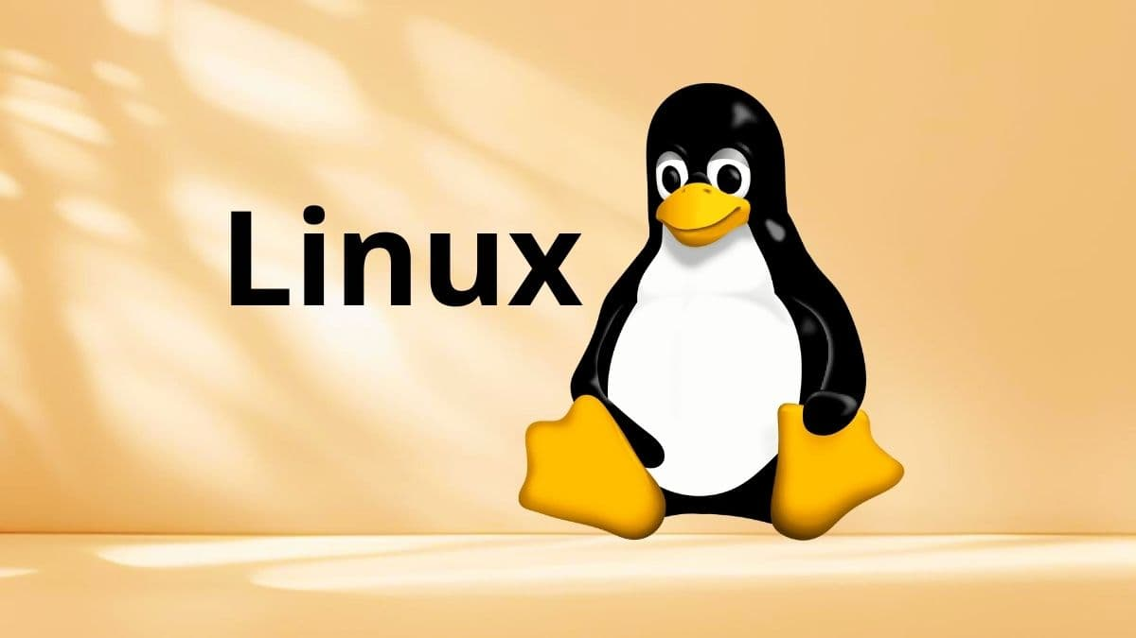

Linux is a free and open-source operating system kernel that was first released by Linus Torvalds in 1991.
It is a versatile and widely adopted operating system that forms the backbone of many academic, industrial, and technological environments. Its robustness, security features, and extensive scripting capabilities make it an essential tool for computer science and IT professionals.
This assignment aims to provide practical, hands-on experience with Linux installation, shell commands, and shell scripting to automate routine tasks.
In this assignment, I learned how to write and run simple shell scripts on Linux. The tasks involved making scripts that help with everyday technical work, like backing up files, monitoring CPU and memory usage, and downloading files from the internet. This work helped me to understand basic Linux commands and how to automate different jobs using a shell script.

LINUX INSTALLATION STEPS
The Linux installation steps are listed below in full detail :-
STEP-1 :- INSTALLING THE UBUNTU LASTEST VERSION
Visit the official site https://ubuntu.com/download/desktop .Click on the “Download for free” button. Now download the “Ubuntu 24.04.3 LTS” version of the ubuntu by clicking on the download button. Then ubuntu will be installed in your system.
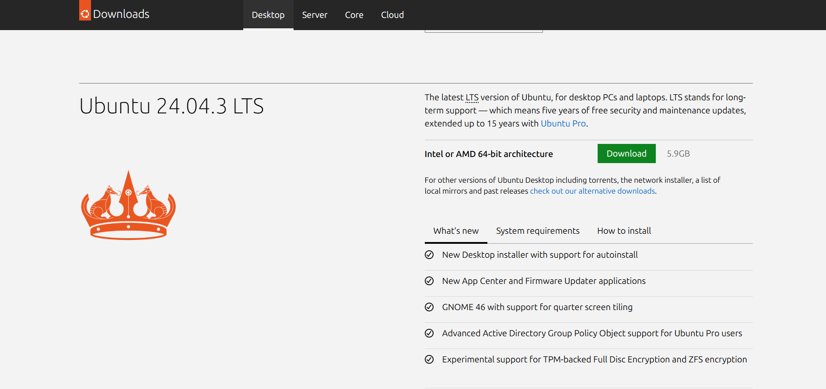
STEP-2 :- INSTALLING THE ORACLE VIRTUAL BOX
Visit the official site https://www.virtualbox.org/. Click on the “Download” button. Now, click on the “windows host” if you are working on windows otherwise select the option according to your system. Then oracle virtual box will be installed in your system.
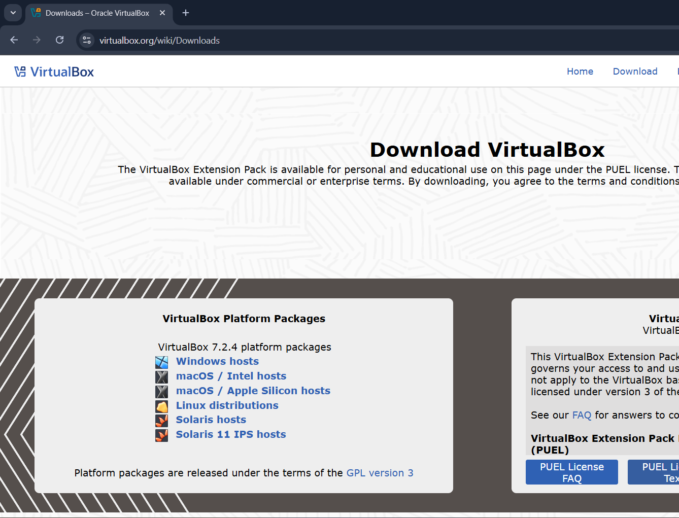
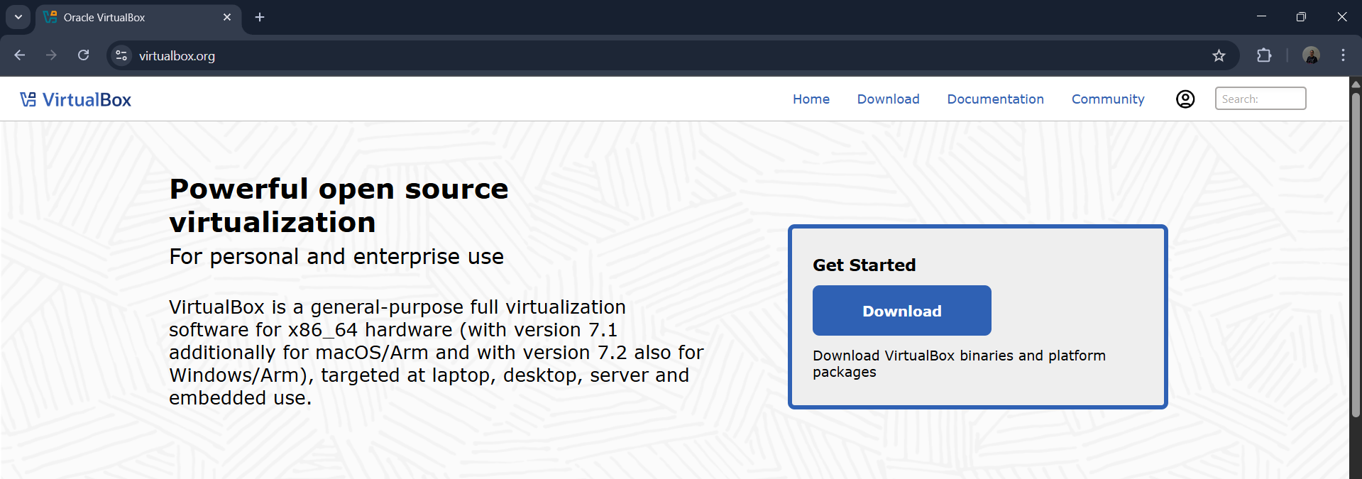

STEP-3 :- SETTING UP THE VIRTUAL BOX TO RUN UBUNTU IN IT
Now open the oracle virtual box and just go with the default options and click next and next and after this install this.
After all this follow the following steps:-
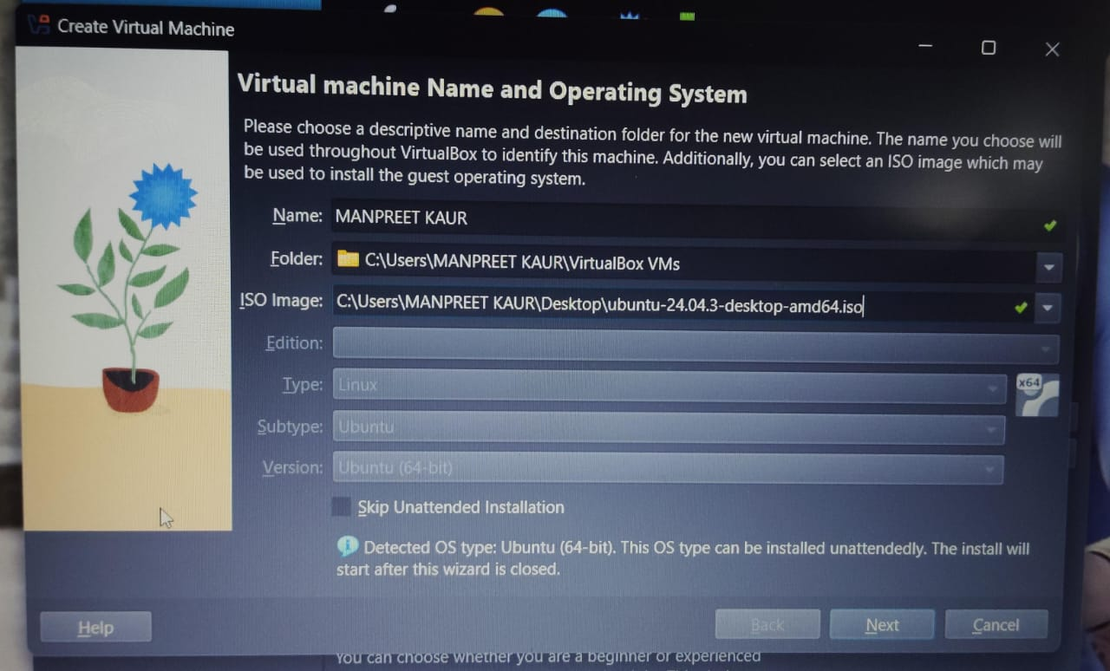
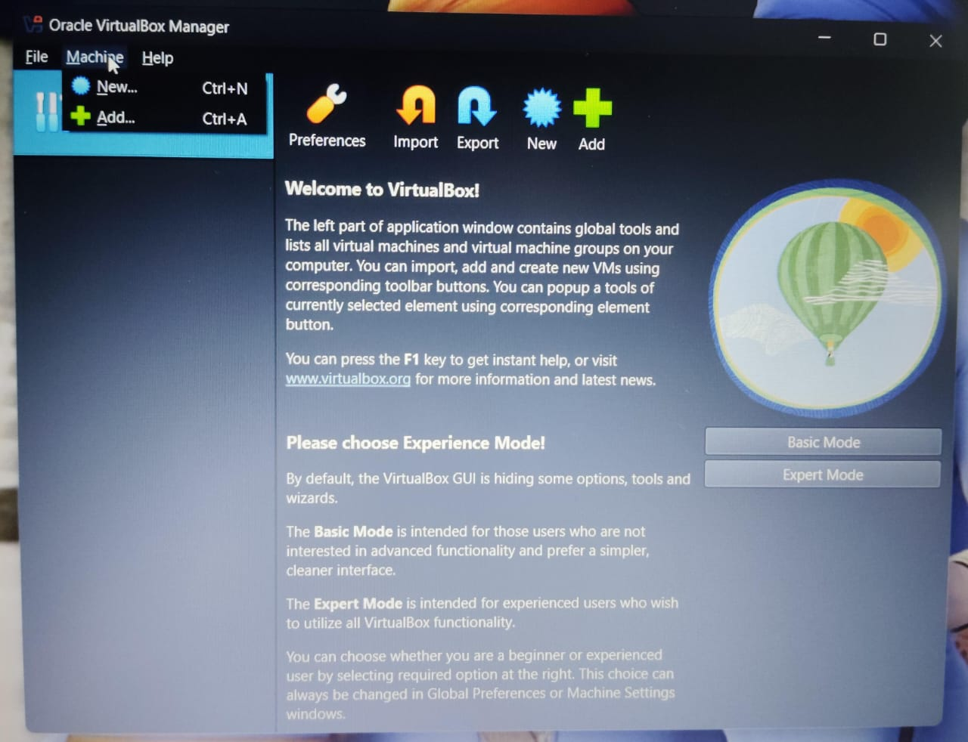
As you can see in the images that , when you open the virtual box you have to click on the “Machine” option. Then on the drop down menu appeared click on the “New” option. After all this you have to do the settings on the virtual machine that you are going to create. Fill the boxes as shown in the images and set your password. After that you have to select some hardware options such as giving the space to the “Base Memory” and the “CPU”. This space is given according to the specifications of the system. I have given the maximum green space to my machine. After this you have to select the virtual hard disk options according to your choice, Here I have selected the option “Create a virtual hard disk now” having the space 25 GB. After that a window will open and all the installation process will start.

Now you are ready to work on Linux by using the Oracle Virtual Box, just open the virtual machine by clicking on the “Start” button and enter your password. After this open the “Terminal” in the virtual machine that you have created. Now you can practice all the Linux commands here easily.

These were all the installation steps ubuntu. For you can also refer the video given here for the installation:-
https://youtu.be/Hva8lsV2nTk?si=TEQ2FOWGN4QURJ_u

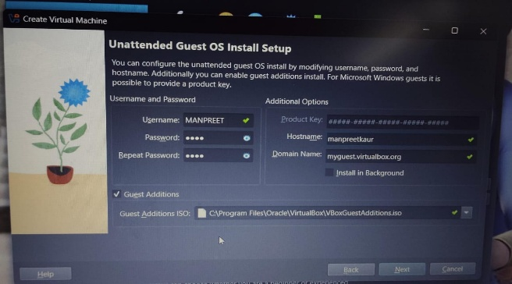

THESE ARE THE SPECIFICATIONS THAT I HAVE GIVEN TO MY ORACLE VIRTUAL BOX.
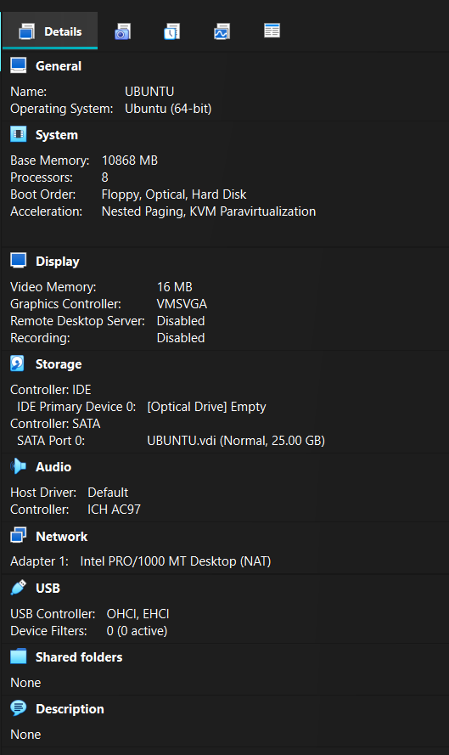
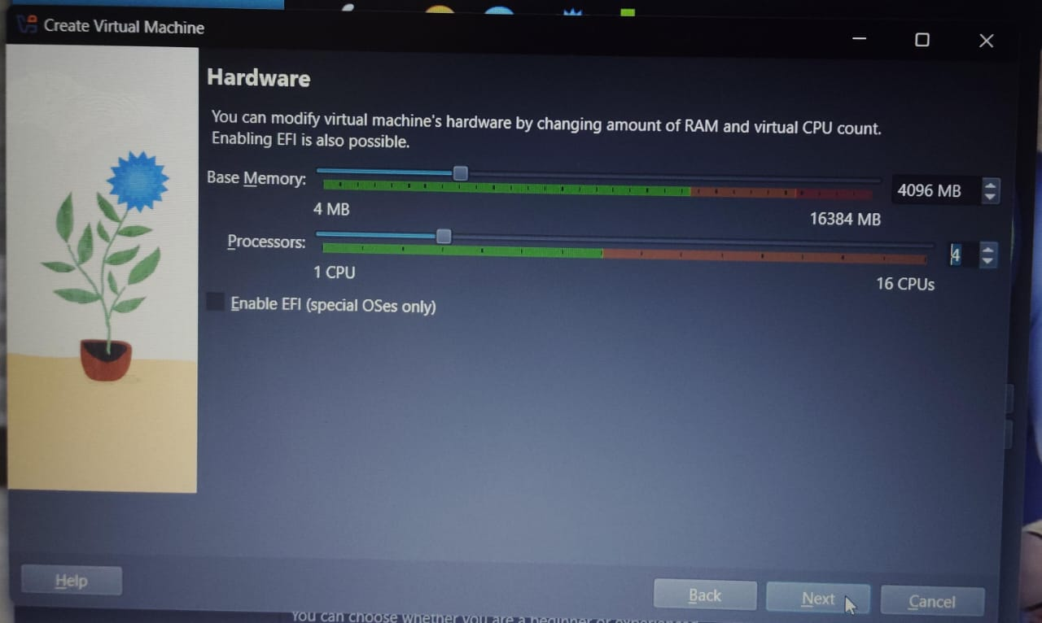
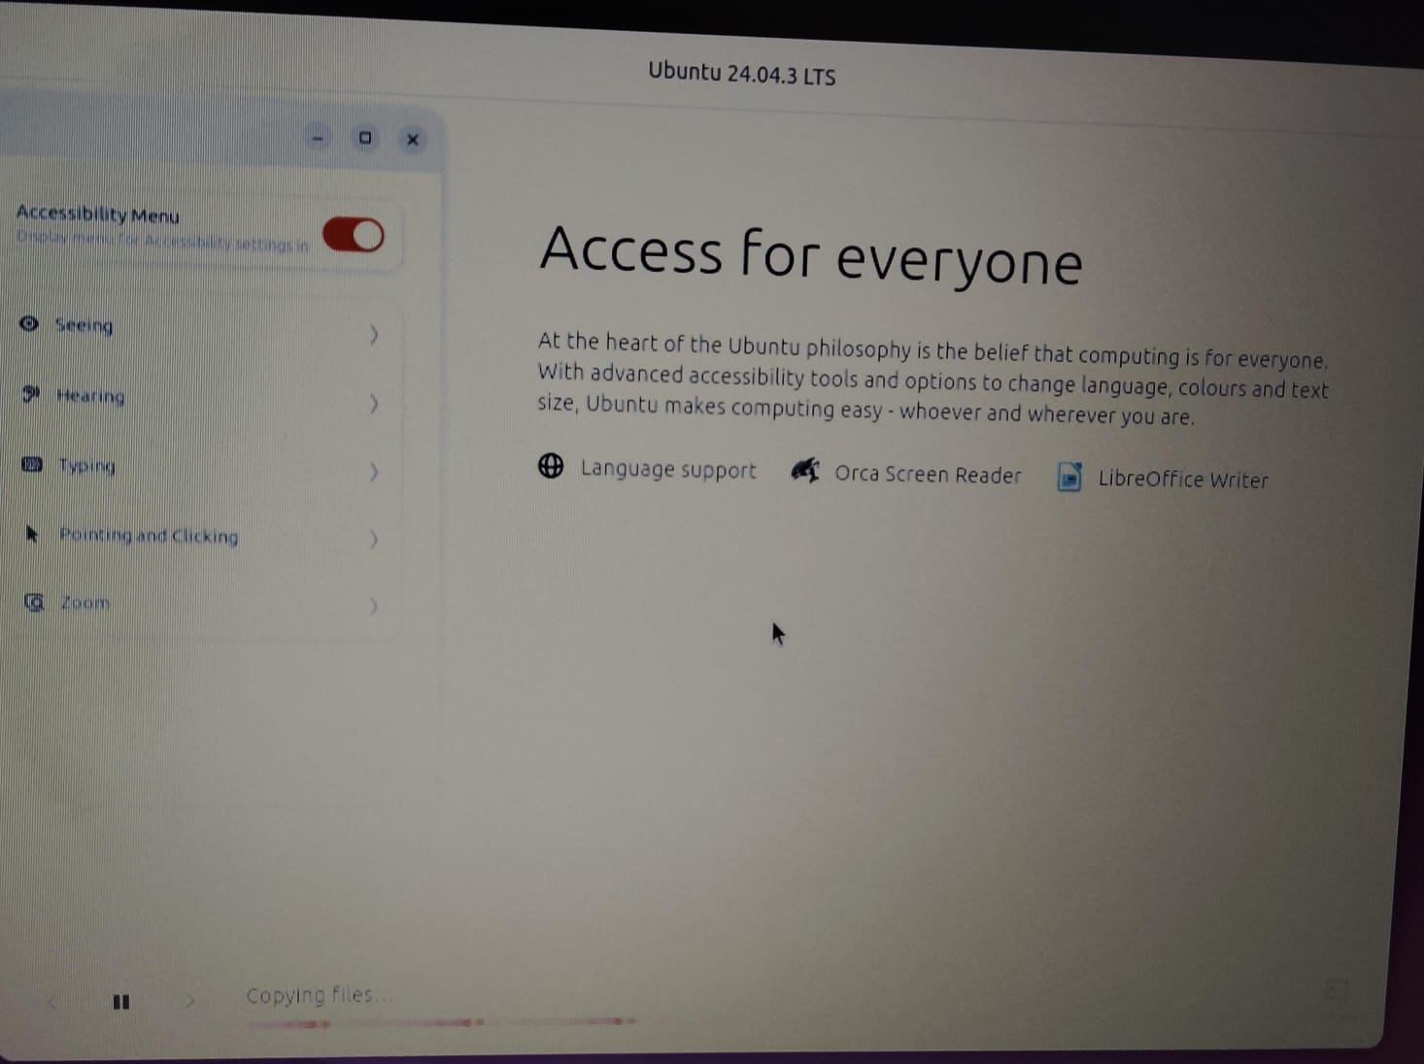
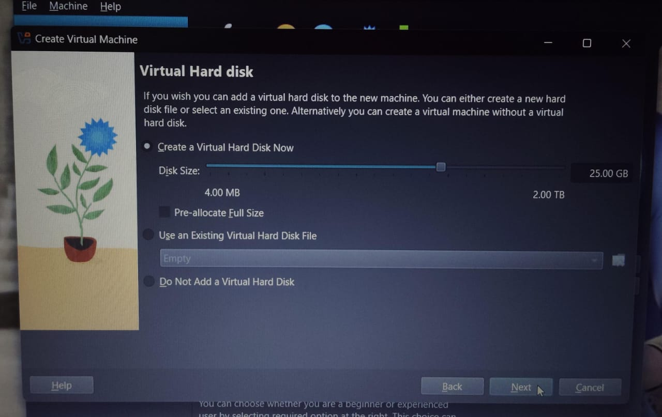
SHELL COMMAND IMPLEMENTATION AND DOCUMENTATION
[A] FILE NAVIGATION COMMANDS
These commands are used to navigate through the file in the system some of these commands such as pwd, ls, cd or tree etc. are listed in this document.
[B] FILE AND DIRECTORY MANAGEMENT COMMANDS
These Linux commands are used in directory and file managements such as creating then, removing them etc.. some of these commands such as mkdir, rmdir, rm, cp, mv, cat, touch or clear etc. are listed in this document.
[C] PERMISSIONS MANAGEMENT COMMANDS
Linux permission management primarily involves controlling who can read, write, and execute files and directories. Some of the commands such as chown and chmod are listed in this document.
[D] PROCESS MONITORING COMMANDS
Linux provides several commands for process monitoring, each offering different levels of detail and real-time capabilities. Some commands such as ps, top, kill etc. are listed in this document.
[E] NETWORKING TOOLS COMMANDS
Linux provides a comprehensive set of command-line networking tools for configuring, managing, and troubleshooting network connections. Some commands such as ping, ifconfig, netstat etc. are listed in this document.
(1) PWD COMMAND
DESCRIPTION :-
This command prints the current working directory, that means it tells you that where you are exactly in the file system hierarchy. The “pwd” command in Linux stands for “Print Current Working directory”.
SYNTAX :- pwd
WHY AND WHEN :-
The pwd command in Linux is used to display the current working directory's full path. It is helpful to know your exact location in the file system, especially when navigating or scripting.
IMPLEMENTATION :-
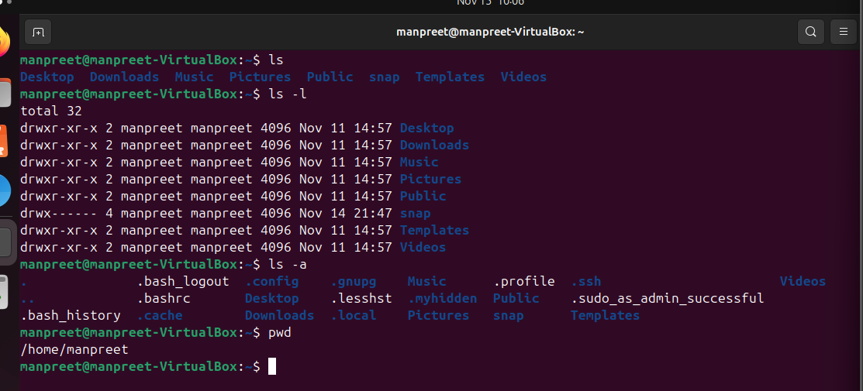
(2) LS COMMAND
DESCRIPTION :-
The “ls” command in Linux is used to list the contents of the directories. When we execute this command without any arguments, it displays the files and subdirectories within the current working directory in alphabetical order.
ls | List all the files / folders
ls -l | To get a detailed view of files / folders
ls -a | To show all the hidden files

SYNTAX :- ls [options] [file/directory]
WHY AND WHEN :-
The ls command in Linux is used to list the files and directories in the current or specified directory. It helps users quickly view what files are present for navigation or management. It’s commonly used to check directory contents efficiently in the terminal.​
IMPLEMENTATION :-

(3) CD COMMAND
DESCRIPTION :-
The “cd” command in Linux is used to navigate the file system. It allows the user to change the current working directory in the terminal. Here “cd” stands for “change directory”.

cd /path | Go to the specified folder
cd .. | Move up to the parent directory.
cd - | Switch to the previous directory.
cd | Jump to the home directory

SYNTAX :- cd [options] [directory]
WHY AND WHEN :-
The cd command is used to change the current working directory in Linux. It is commonly used whenever you need to navigate to a different directory to access or manage files efficiently in the command line environment
IMPLEMENTATION :-
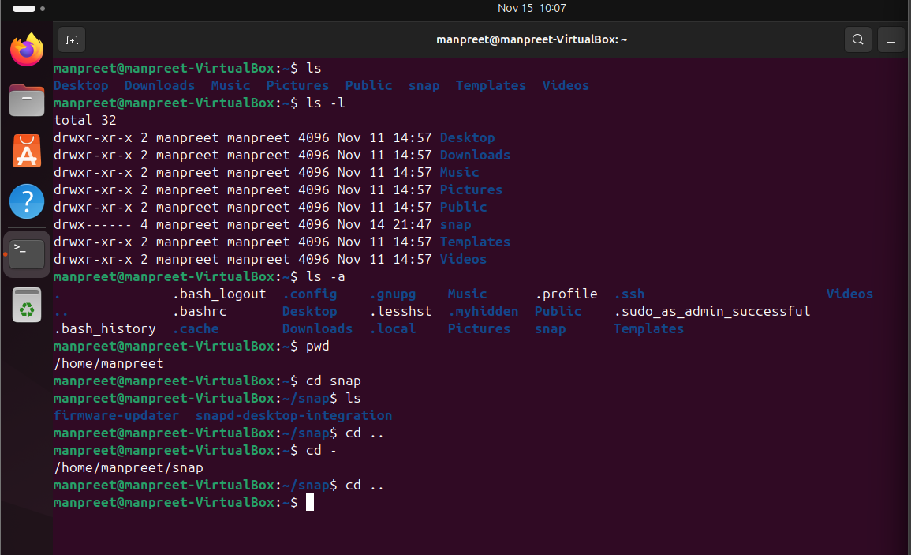
(4) TREE COMMAND
DESCRIPTION :-
The tree command in Linux displays the directory structure in a clear tree-like format, showing files and subdirectories hierarchically.
SYNTAX :- tree
WHY AND WHEN :-
The tree command is used to quickly visualize the hierarchical structure of directories and files. It is helpful when you want to see the organization and nesting within a directory in a clear, easy-to-understand format.
IMPLEMENTATION :-
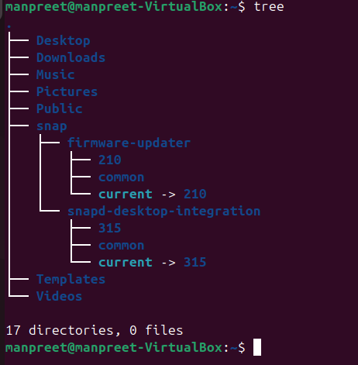
(5) MKDIR COMMAND
DESCRIPTION :-
The command “mkdir” refers to “make directory”. This Linux command is used to create new directories in the file system.
SYNTAX :- mkdir [directory_name]
WHY AND WHEN :-
This command is used to create directories in the file systems. It is useful for organizing files by creating one or multiple directories quickly.
IMPLEMENTATION :-
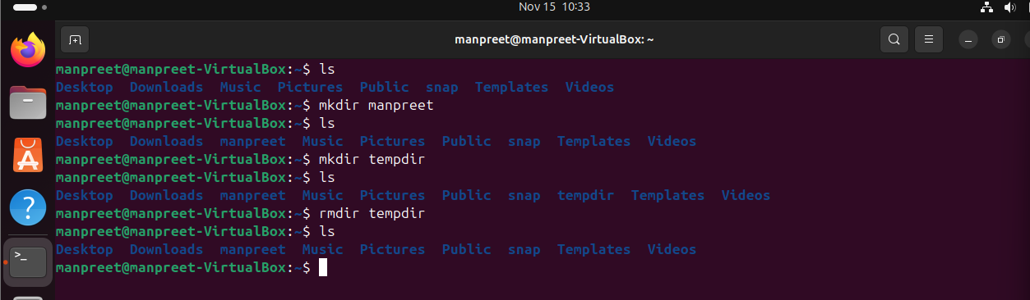
(6) RMDIR COMMAND
DESCRIPTION :-
The command “rmdir” refers to “remove directory”. This Linux command is used to remove an empty directory in the file system.
SYNTAX :- rmdir [directory]
WHY AND WHEN :-
This Linux command is used to remove the empty directories from the file system. It can only delete directories that do not contain any files or subdirectories, ensuring safe deletion without risking the loss of data inside. Commonly , this is used for cleaning up and managing the directory structures safely deleting unused or temporary empty folders.
IMPLEMENTATION :-

(7) CAT COMMAND
DESCRIPTION :-
The name “cat” command means “concatenate”. It is used to display the content of files, concatenate multiple files, and redirect output to create or append to files.
SYNTAX :-
Viewing file content :- cat [filename]
Combining files :- cat [file1] [file2]
Creating or editing files with input redirection :- cat > [newfile]
WHY AND WHEN :-
The “cat” command in Linux is used to display the content of the file on the terminal or combine multiple files. It is commonly used to quickly view file contents or create new files by redirecting input. Its simplicity and versatility make it essential for file manipulation and quick content check.
IMPLEMENTATION :-
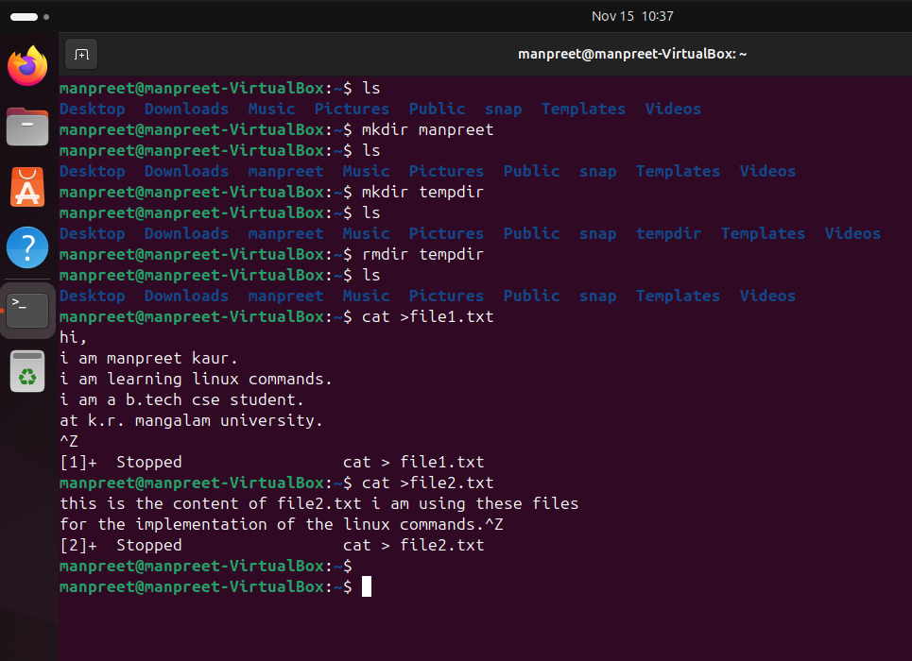
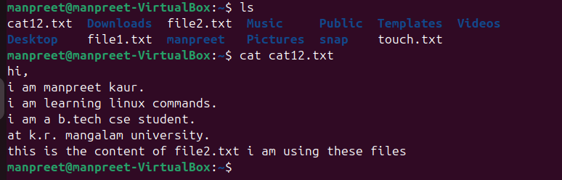
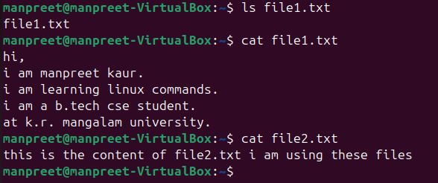
(8) RM COMMAND
DESCRIPTION :-
The name “rm” stands for “remove files”. This command in Linux is used to permanently delete files. With options like -r for recursive deletion and -f for force deletion, it can remove directories and their contents safely and efficiently.
SYNTAX :- rm [options] [file]
WHY AND WHEN :-
This command is commonly used to remove unwanted files quickly from the command line. Use it with caution, as deleted files are not moved to a recycle bin and cannot be easily recovered.
IMPLEMENTATION :-
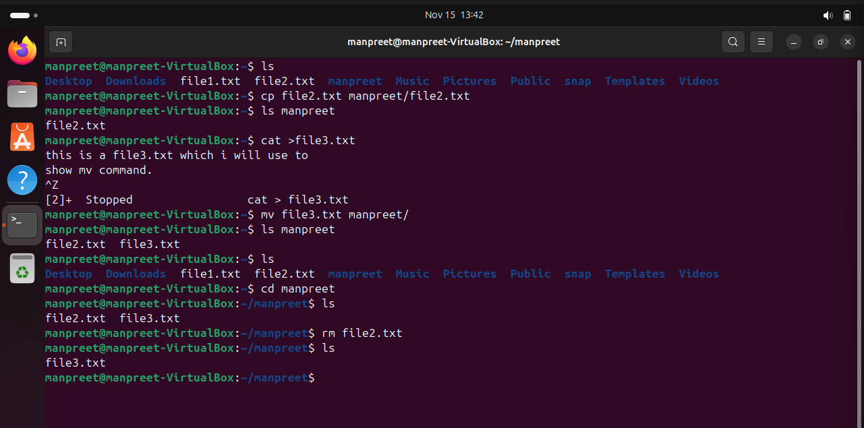
(9) CP COMMAND
DESCRIPTION :-
The name “cp” stands for “copy files”. This command is used to copy files or directories from one location to another.
SYNTAX :- cp [options] source destination
WHY AND WHEN :-
This command is mainly used when you want to duplicate files for backup, sharing or organizing data. This command is simple yet powerful for managing file copies efficiently within the Linux file system.
IMPLEMENTATION :-
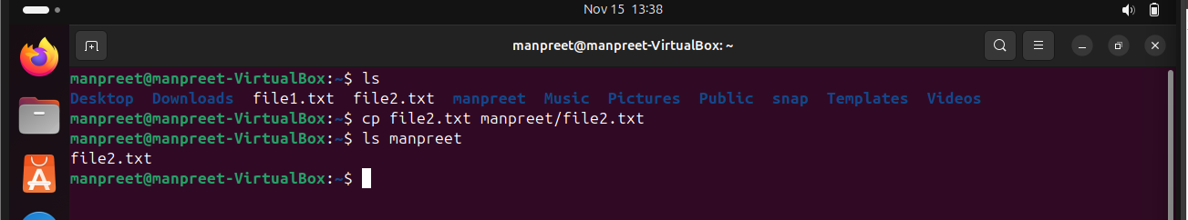
(10) MV COMMAND
DESCRIPTION :-
The word “mv” stands for “move files”. This command in Linux is used to move or rename files and directories.
SYNTAX :- mv [options] source destination
WHY AND WHEN :-
It moves files or directories from a source location to a destination. It can also rename files or directories by moving them to the same location with a different name. It is useful in organizing files, renaming files without copying/deleting.
IMPLEMENTATION :-
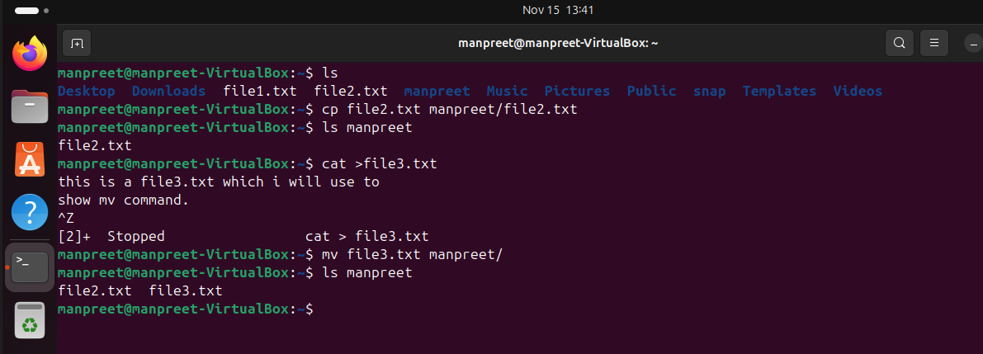
(11) CLEAR COMMAND
DESCRIPTION :-
The “clear” command in Linux is used to clear the terminal screen, removing all previous commands and output from the visible area.
SYNTAX :- clear
WHY AND WHEN :-
It provides a clean workspace without closing the terminal session or deleting the command history. This command is useful for decluttering the terminal and improving readability during command-line work.
IMPLEMENTATION :-
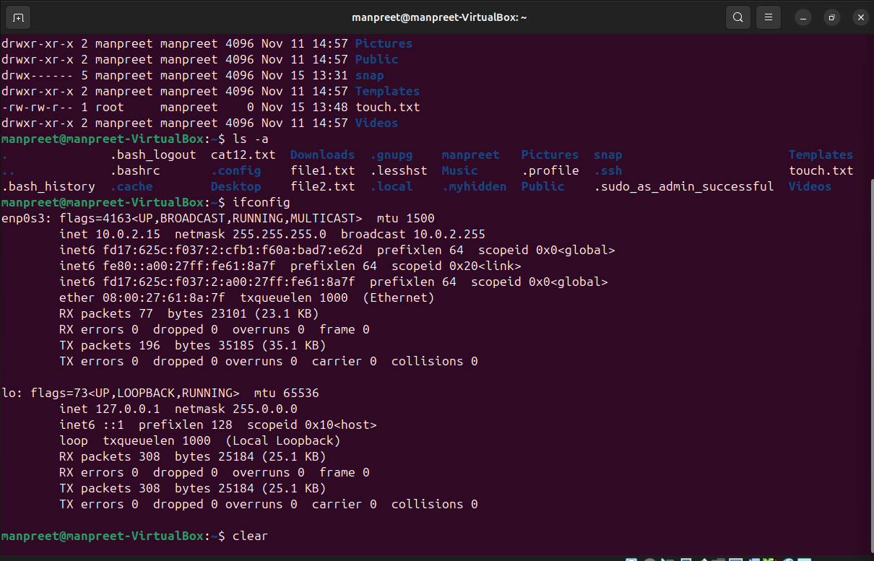
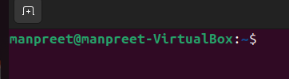
(12) HEAD COMMAND
DESCRIPTION :-
The “head” command in Linux is used to display the first few lines of a text file directly in the terminal. By default, it shows the first 10 lines but allows customization to show a specific number of lines or bytes.
SYNTAX :- head [options] [files]
WHY AND WHEN :-
It is commonly used to quickly preview the beginning of a log file, configuration file, or any large text file without opening the entire file. This makes “head” useful for quick inspection and troubleshooting in Linux environment.
IMPLEMENTATION :-
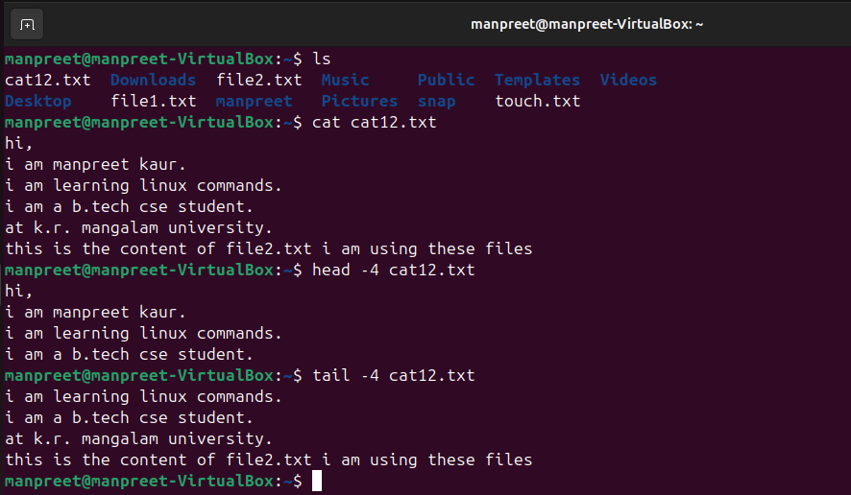
(13) TAIL COMMAND
DESCRIPTION :-
The “tail” command in Linux is used to display the last part of a file, typically the last 10 lines by default. It is commonly used to monitor log files or view recent updates added to files.
SYNTAX :- tail [options] [files]
WHY AND WHEN :-
The “tail” command helps quickly see the most recent content of a file and is essential for system administration and debugging tasks. This makes “tail” especially valuable for viewing recent parts of files or monitoring live updates.
IMPLEMENTATION :-

(14) CHMOD COMMAND
DESCRIPTION :-
The “chmod” stands for “change mode”. This command in Linux is used to change the permissions (read, write and execute) of files and directories. These permissions determine who can access or modify the file or directory.
SYNTAX :- chmod [options] mode file
WHY AND WHEN :-
It allows setting permissions for the owner, group and others. Permissions can be set using symbolic (eg- u+rwx) or numeric (eg-755) modes. It helps control access and security for files and directories. This is essential for managing file security and controlling user access in Linux systems.
IMPLEMENTATION :-
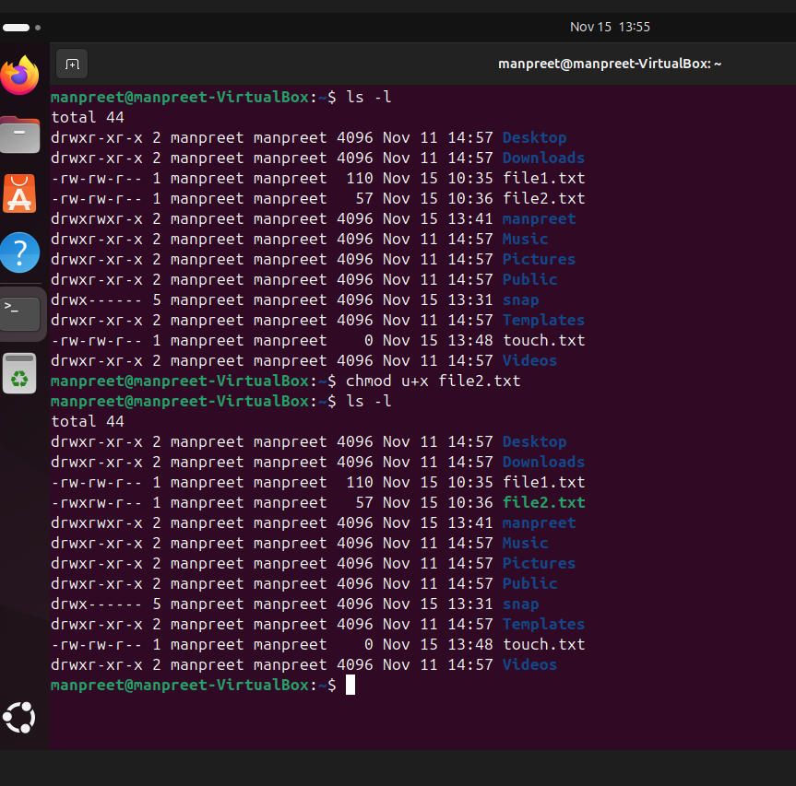
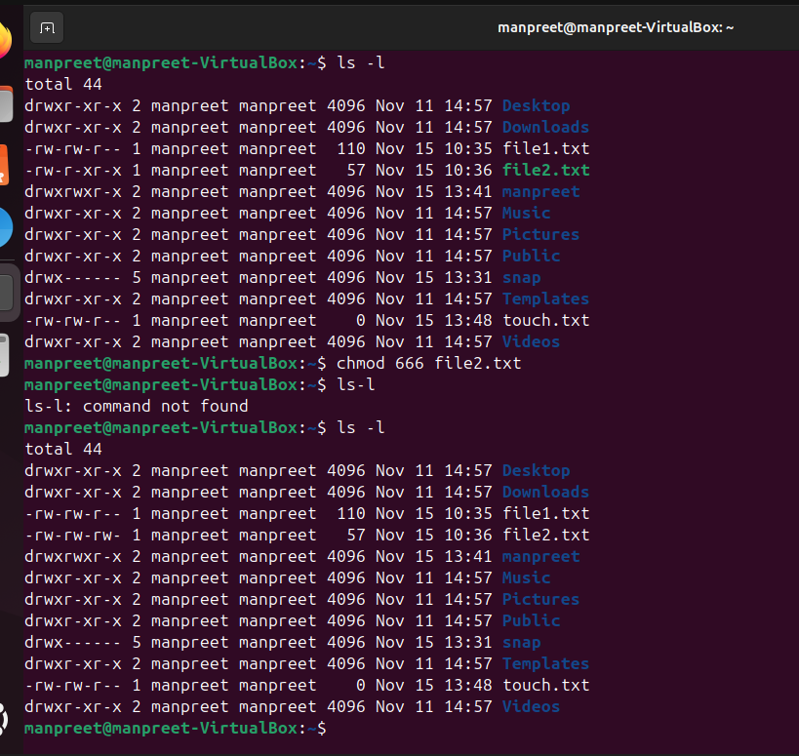
(15) CHOWN COMMAND
DESCRIPTION :-
The “chown” stands for “change owner”. This command is used to change the ownership of files or directories. It allows changing the user (owner) and optionally the group associated with a file or directory.
SYNTAX :- chown [options] new_owner[:new_group] files
WHY AND WHEN :-
It supports changing just the owner, just the group or both simultaneously. Commonly used to manage file permissions and access control on multi-user systems. Only the root user or the current file owner with proper permissions can change the ownership.
IMPLEMENTATION :-
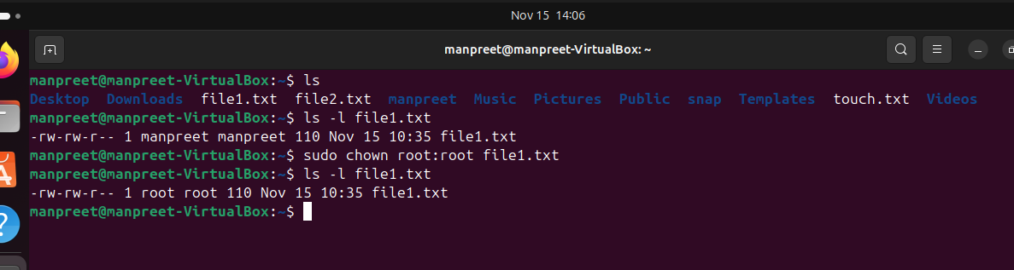
(16) PS COMMAND
DESCRIPTION :-
The “ps” command in Linux is used to display information about active processed running on the system. It provides a snapshot view of current processed for the current user or all users depending on options.
SYNTAX :- ps [options]
WHY AND WHEN :-
It is useful for monitoring and managing system processes, reports processes for the current user or all users depending on options and can display detailed information or a simple list based on flags. “ps” is an essential command for system monitoring and process management in Linux.
IMPLEMENTATION :-
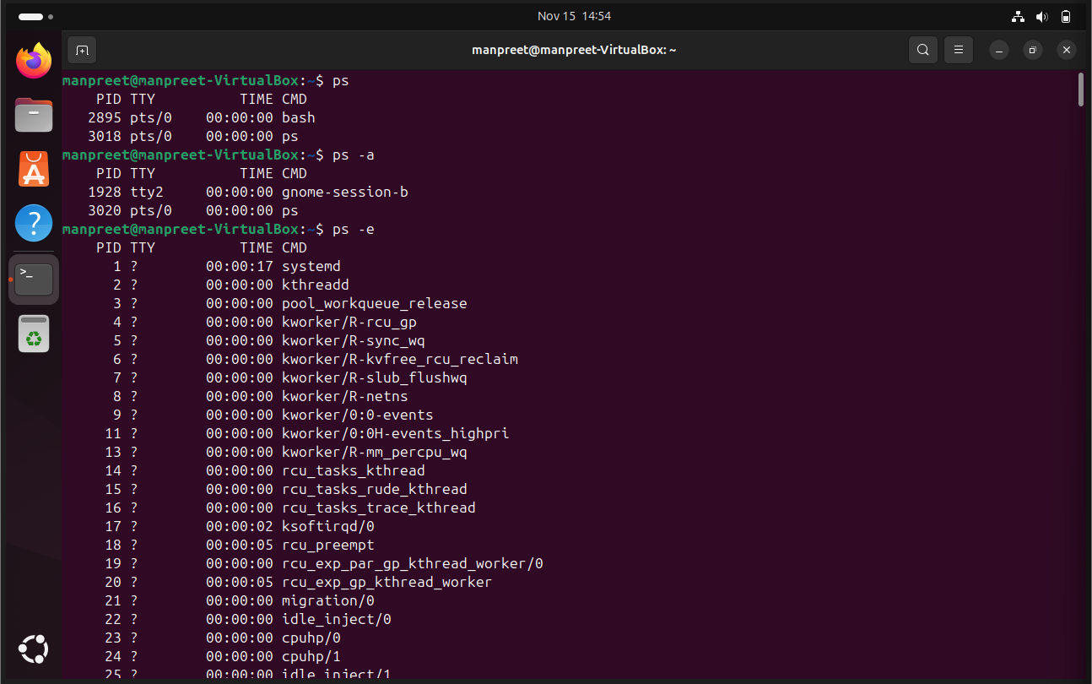
(17) TOP COMMAND
DESCRIPTION :-
The “top” command in Linux provides a dynamic, real-time view of running processes and overall system resource usage. It displays system statistics including CPU and memory usage, process information and system load averages.
SYNTAX :- top
WHY AND WHEN :-
This command shows the active processes with PID, user, CPU, memory and runtime. It displays system uptime, number of users and load averages and many more things. This command is essential for monitoring system performance and manging processes in Linux.
IMPLEMENTATION :-
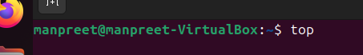
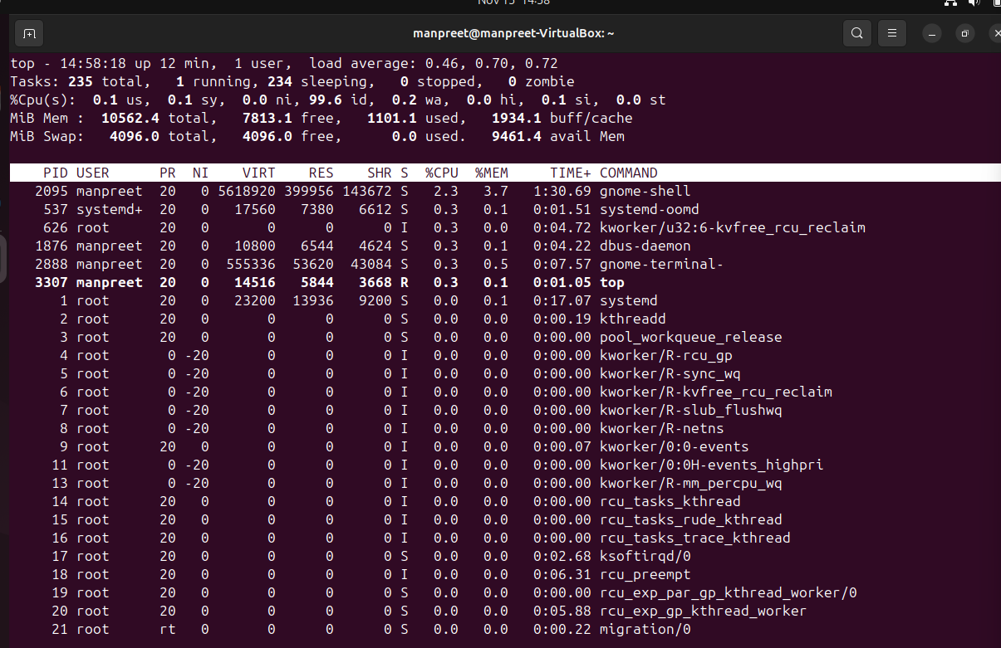
(18) KILL COMMAND
DESCRIPTION :-
The “kill” command is used to send signals to processes, typically to terminate them. It sends a termination signal to process by its process ID (PID).
SYNTAX :- kill [signal] <PID>
WHY AND WHEN :-
This command is essential for managing and controlling the processes that run on the Linux system. Basically, it terminates the processes that we don’t need.
IMPLEMENTATION :-
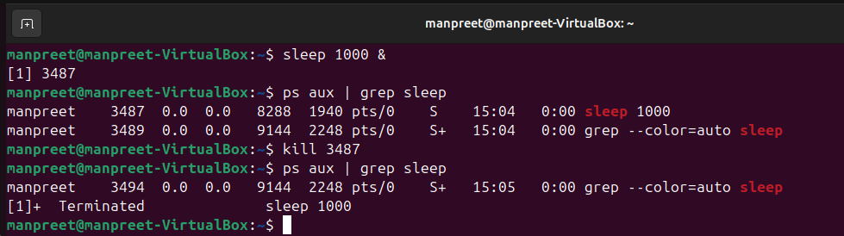
(19) PING COMMAND
DESCRIPTION :-
The “ping” command is a network utility command used to test the reachability of a host on an IP network and measure the round-trip time for messages sent from the originating host to a destination computer.
SYNTAX :- ping [options] destination
WHY AND WHEN :-
This command helps troubleshoot network connectivity by confirming whether a remote host is reachable and how long data packets take to travel there and back. It is one of the most commonly used commands for network diagnostics in Linux systems.
IMPLEMENTATION :-
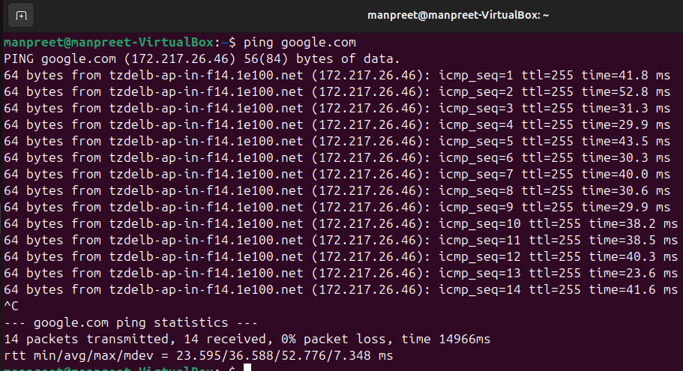
(20) IFCONFIG COMMAND
DESCRIPTION :-
The “ifconfig” command in Linux is used to configure and display network interfaces. It can show information about network interfaces, assign IP addresses, activate or deactivate interfaces, and set various parameters.
SYNTAX :- ifconfig [interface] [options]
WHY AND WHEN :-
“ifconfig” is a powerful network management tool that configures network interfaces, displays IP addresses, netmasks and hardware addresses and controls interface states. This commands is considered legacy on some Linux distributions, replaced by the “ip’ command, but it is still widely used for network interface management.
IMPLEMENTATION :-
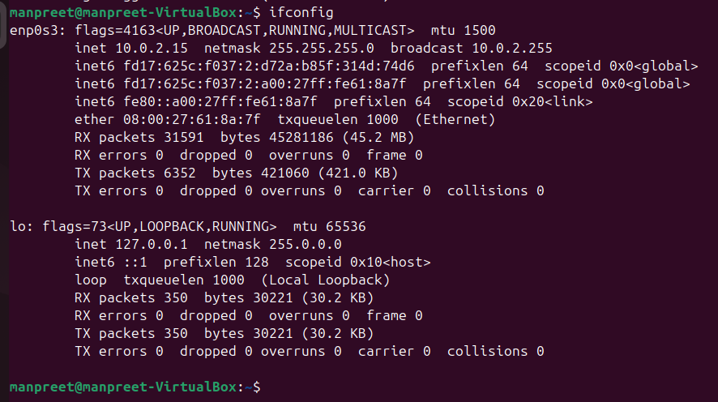
(21) TOUCH COMMAND
DESCRIPTION :-
The ”touch” command in Linux is mainly used to create empty files or update the access and modification timestamps of existing files without changing their content.
SYNTAX :- touch [options] file_name
WHY AND WHEN :-
This command creates a new empty file if the file does not already exists, updates the access and modification times of an existing file to the current time and can also be used to set specific timestamps using options. Overall, this command is useful for scripting, file management and controlling file time attributes.
IMPLEMENTATION :-
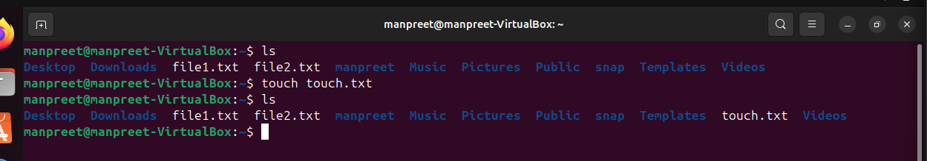
(22) WHOAMI
DESCRIPTION :-
The “whoami” command in Linux displays the username of the current effective user-that is, the username under which the current process is running. This command can run without options also.
SYNTAX :- whoami [options]
WHY AND WHEN :-
This command simply prints the logged-in user’s name. it is useful for verifying the user identity, especially after switching users with commands like “sudo”. This command is often used in scripts to check or confirm the user running the scripts.
IMPLEMENTATION :-
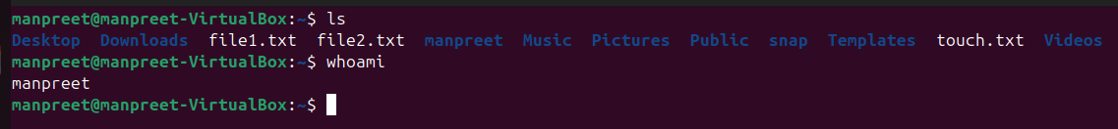
(23) NETSTAT COMMAND
DESCRIPTION :-
The “netstat” command in Linux is a network utility command used to display network connections, routing tables, interface statistics and multicast memberships etc.. It is commonly used for actively, showing which ports are open, active connections and which process is using a specific port.
SYNTAX :- netstat [options]
WHY AND WHEN :-
This command is essential for network administrators for monitoring and troubleshooting network issues. This command provides the detailed information on active TCP and UDP connections, displays listening ports, routing tables, and network interface statistics and helps diagnose network issues and monitor network traffic.
IMPLEMENTATION :-
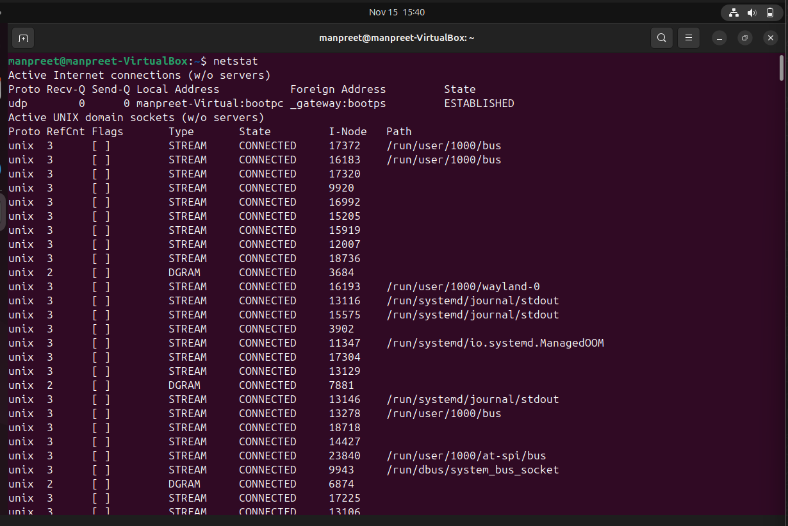
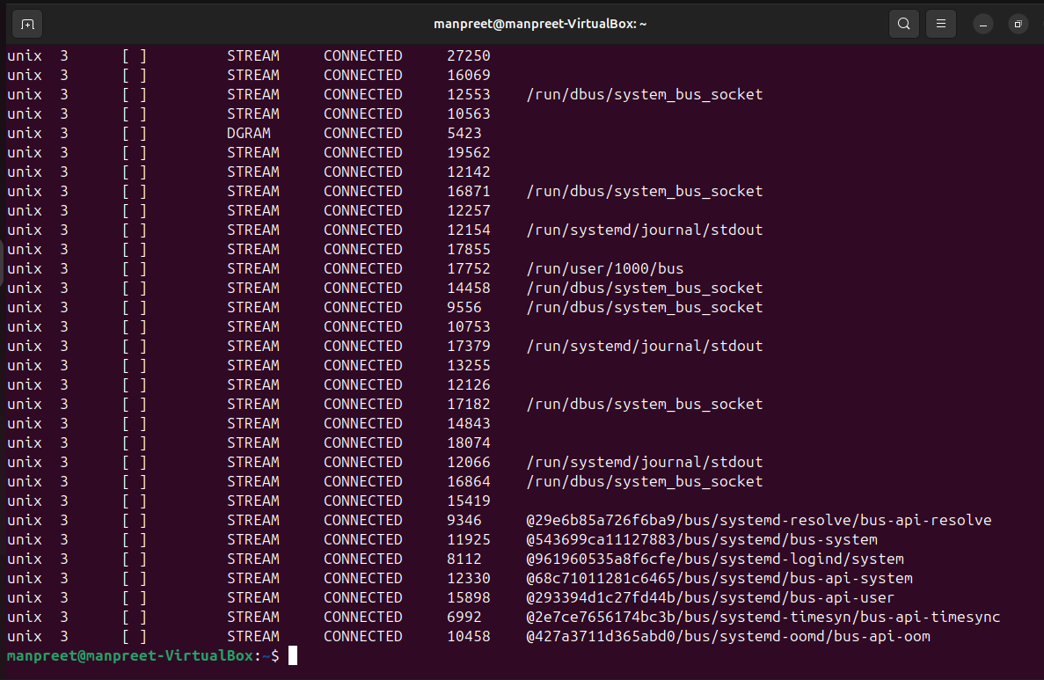
SHELL SCRIPT DEVELOPMENT
BACKUP A DIRECTORY
A script that copies a specified directory to a backup folder with a timestamp.
The output of the script along with the script itself is shown in the snapshots below :-
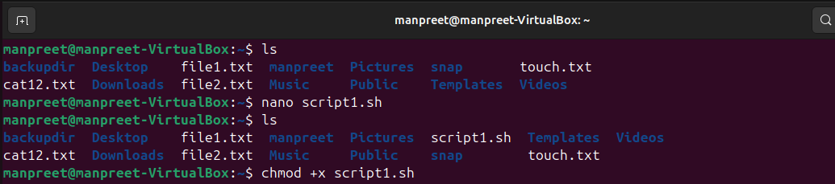
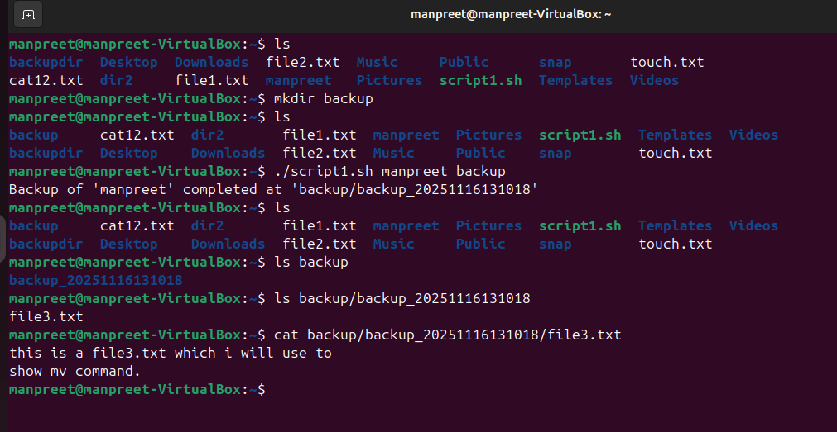
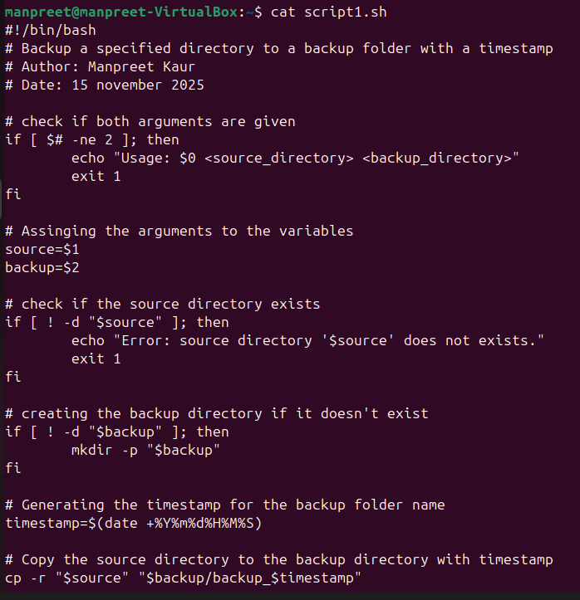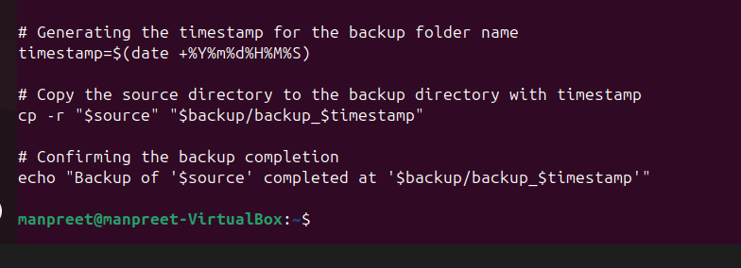
CPU/ MEMORY MONITORING
A script that logs CPU and memory usage to a file at regular intervals.
The output of the script along with the script itself is shown in the snapshots below :-
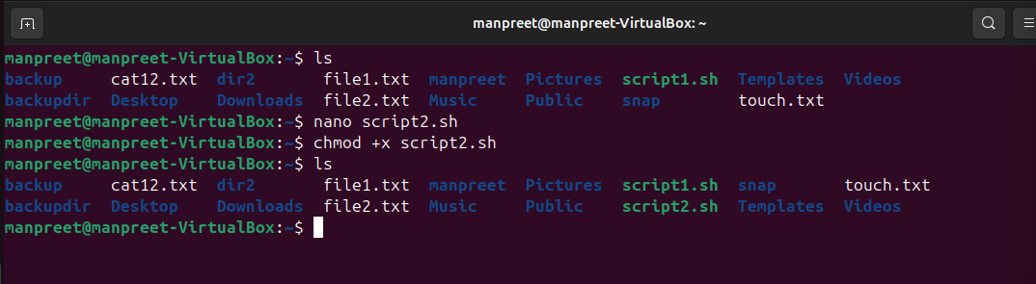
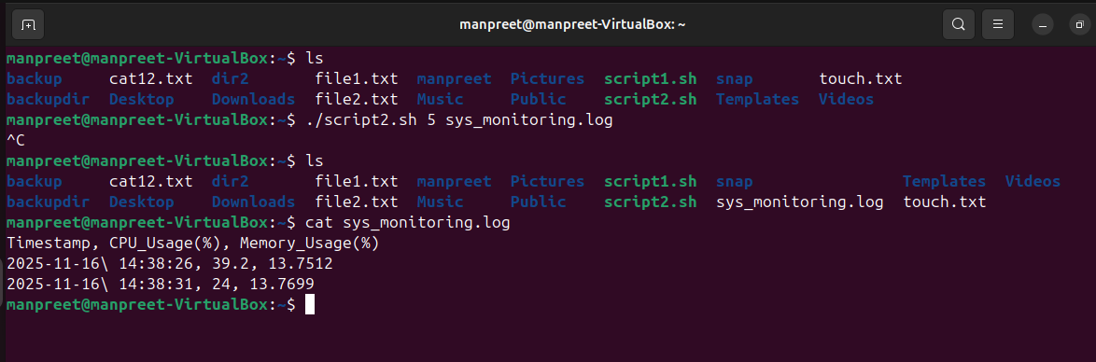
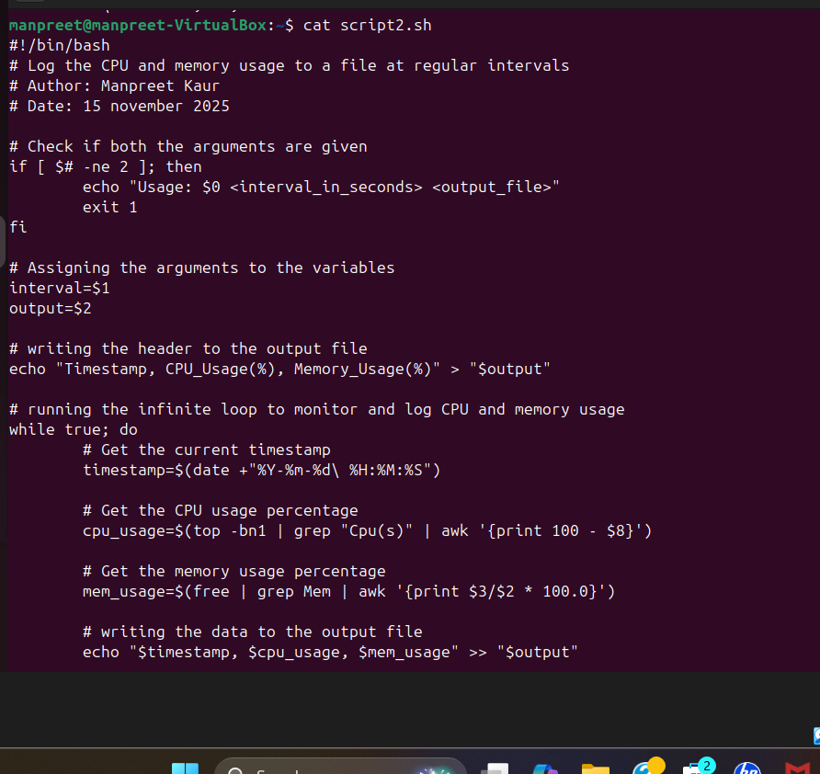
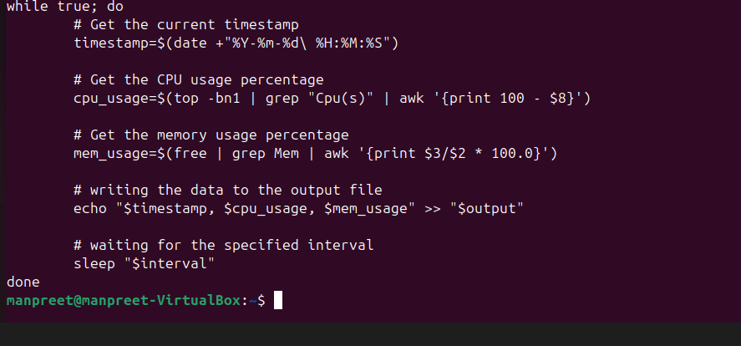
AUTOMATED DOWNLOAD TASK
A script that downloads a file from the internet using “wget” or “curl” and store it in a predefined directory.
The output of the script along with the script itself is shown in the snapshots below :-
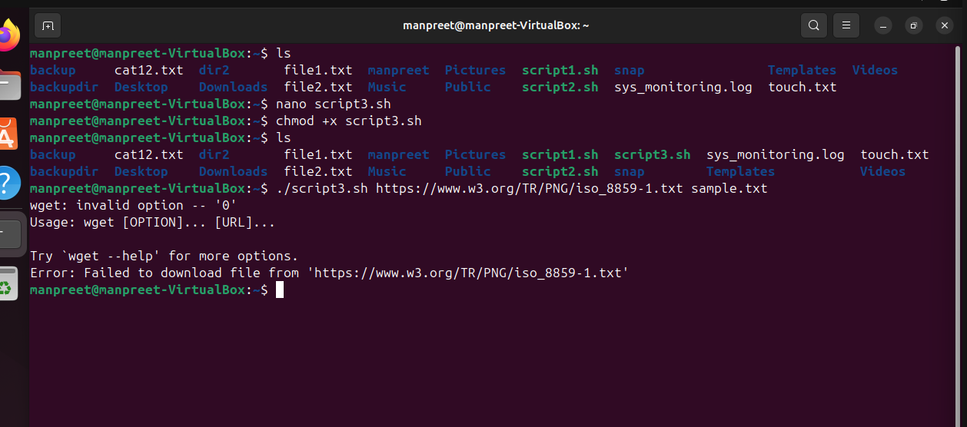
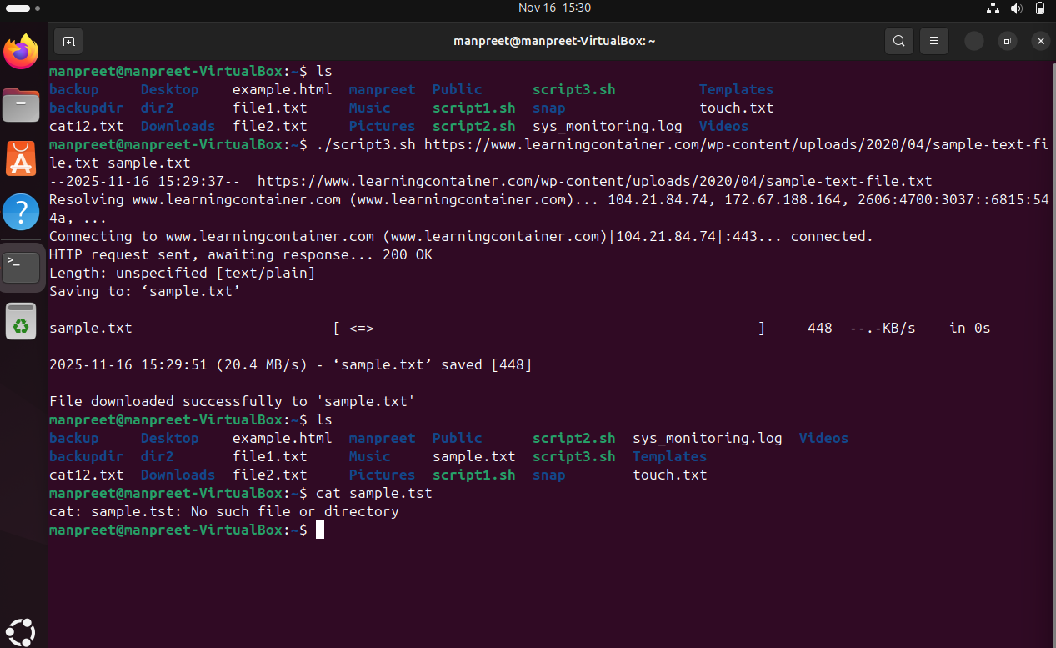

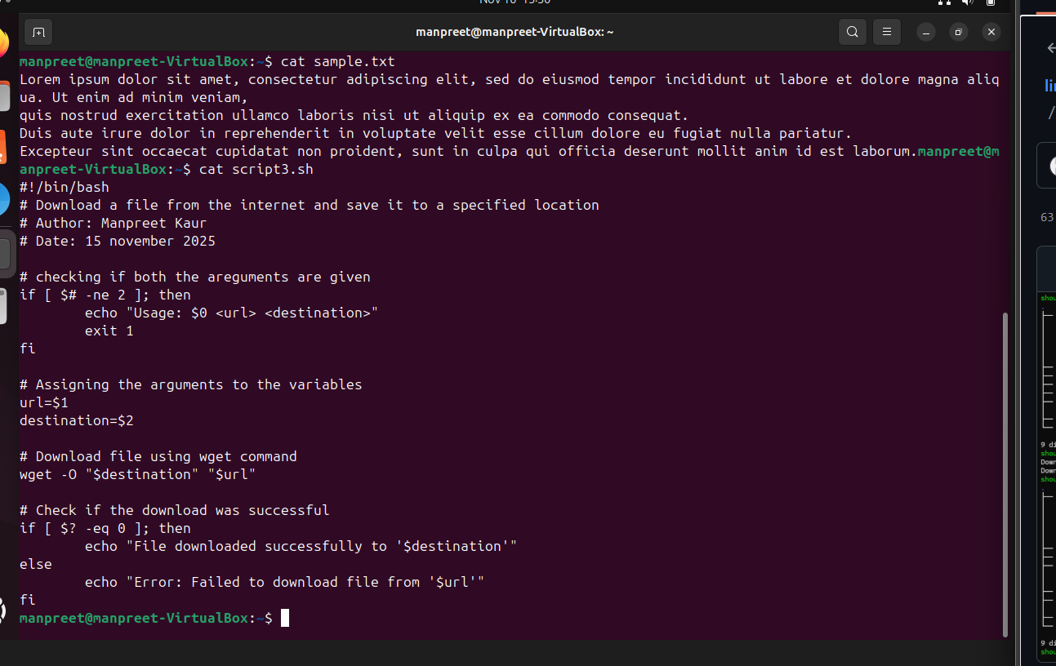
GITHUB REPOSITORY LINK
https://github.com/manpreetkaur292006-design/LINUX-COMMANDS-AND-SCRIPT
REFLECTION
While doing this assignment, I got practical experience in using and combining Linux commands inside scripts, which made many jobs easier and faster. I learned how to check arguments, create and manage directories, and handle errors in my scripts. These skills will be very useful for my future studies and work, because scripting is important for any computer professional. I also gained confidence in using the terminal and writing scripts, which will help me with more advanced topics later on.
THANK YOU

